Lambda & APIGateway-Assignment-01

- Task Title: S3 Event Notification using AWS Lambda
- Objective:
To configure an S3 Event Notification using AWS Lambda and Amazon SNS so that whenever an object is uploaded to an S3 bucket, the event is captured, processed by a Lambda function, and a notification is sent to the subscribed email endpoint via SNS.
- Prerequisites:
• AWS account with access to S3, Lambda, SNS.
• An S3 bucket
• An email address subscribed SNS topic
- Step-by-Step Implementation (With Evidence):
Step 1:
• Console path / CLI command:
AWS Console → Lambda → Functions → Create function
• Explanation:
Created a Lambda function from scratch using Python runtime. The function code logs the incoming S3 event and returns a success response.
Evidence:
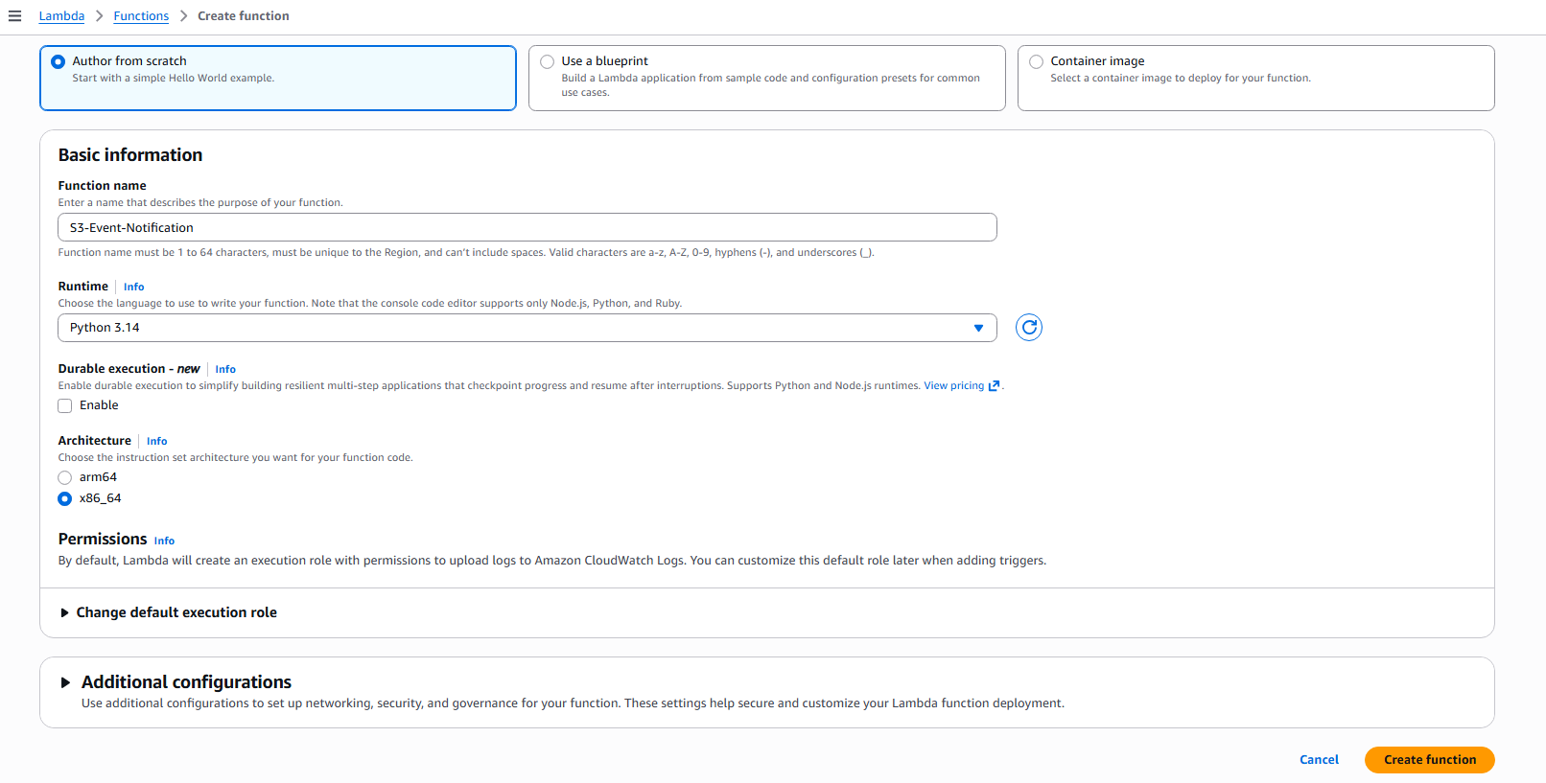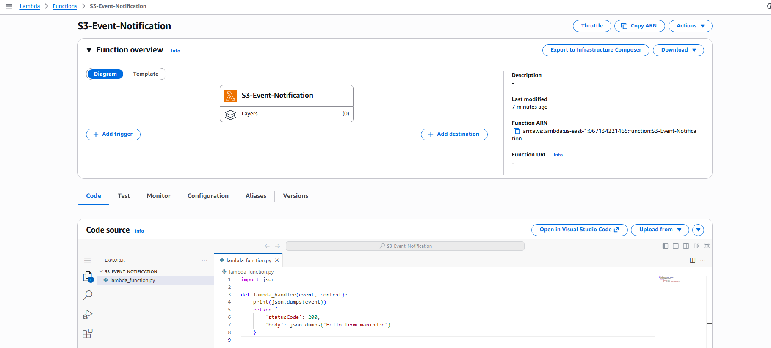
Step 2:
• Console path / CLI command:
AWS Console → Lambda → Function → Test
• Explanation:
Tested the Lambda function using a sample test event to verify the function execution and CloudWatch log generation.
Evidence:
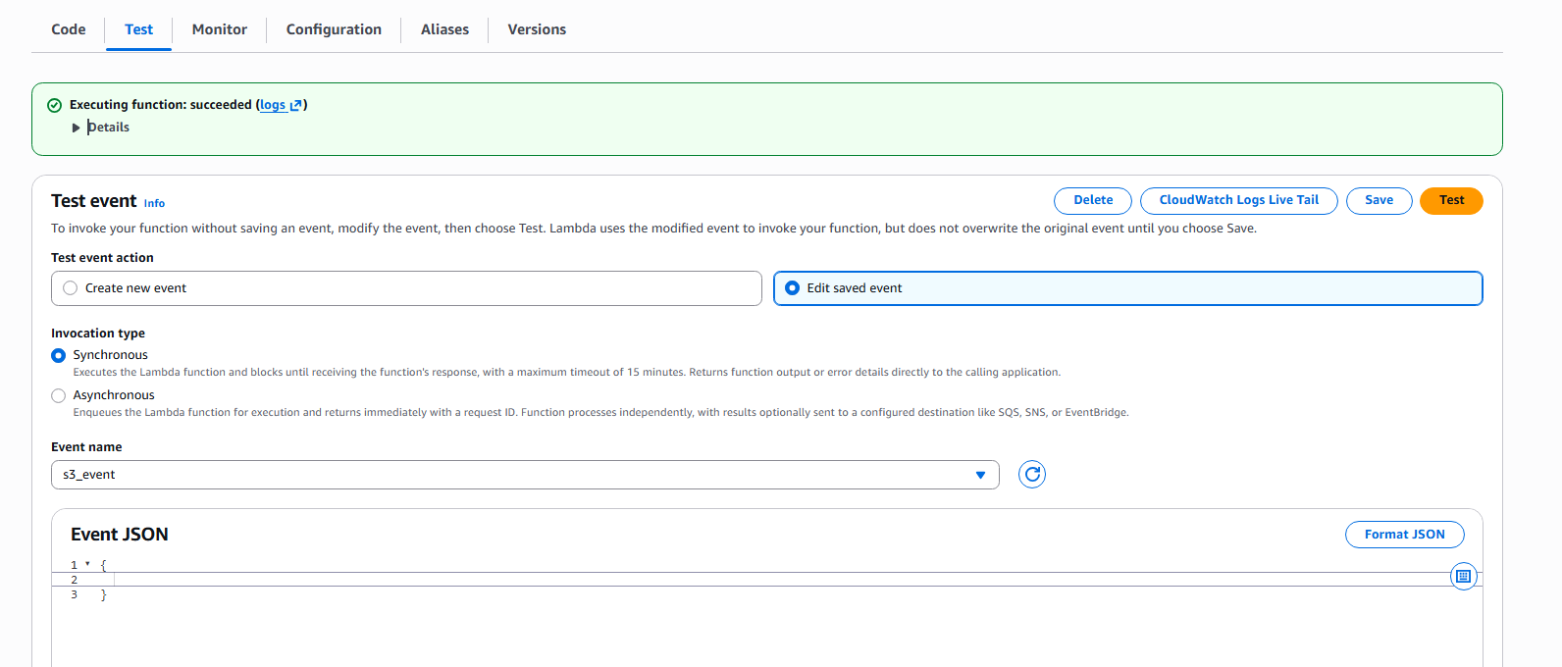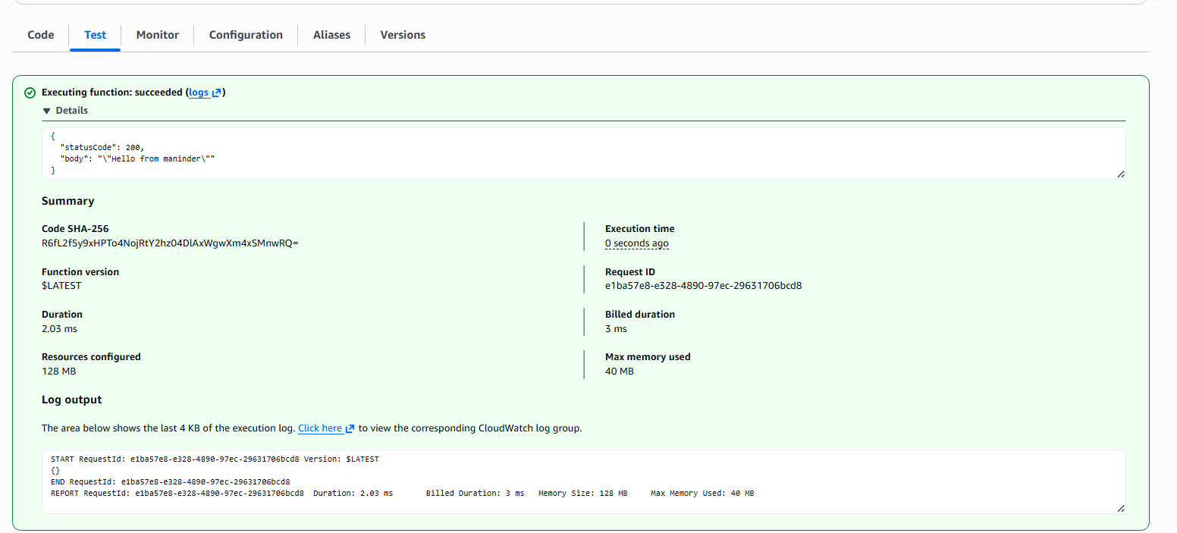
Step 3:
• Console path / CLI command:
AWS Console → S3 → Buckets → Create bucket
• Explanation:
Created an S3 bucket that will act as the event source for triggering the Lambda function.
Evidence:
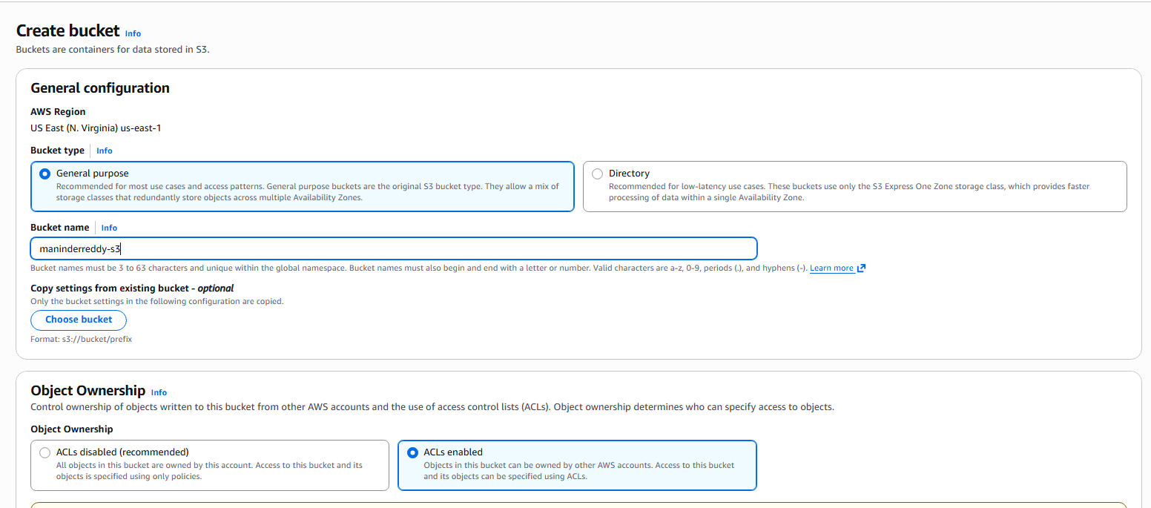
Step 4:
• Console path / CLI command:
AWS Console → S3 → Bucket → Properties → Event notifications → Create event notification
• Explanation:
Configured an S3 event notification to trigger on object creation events with optional prefix and suffix filters, and selected the Lambda function as the destination.
Evidence:
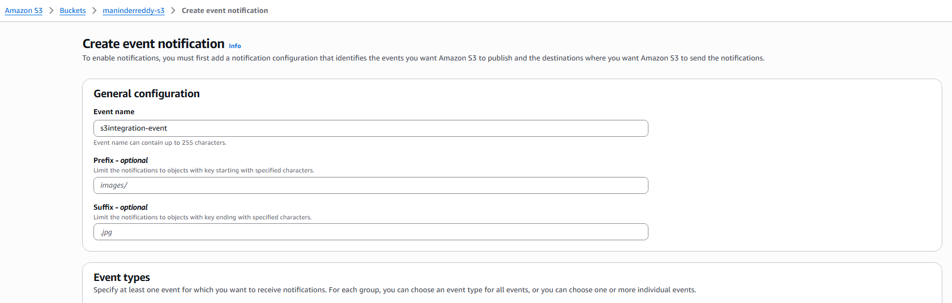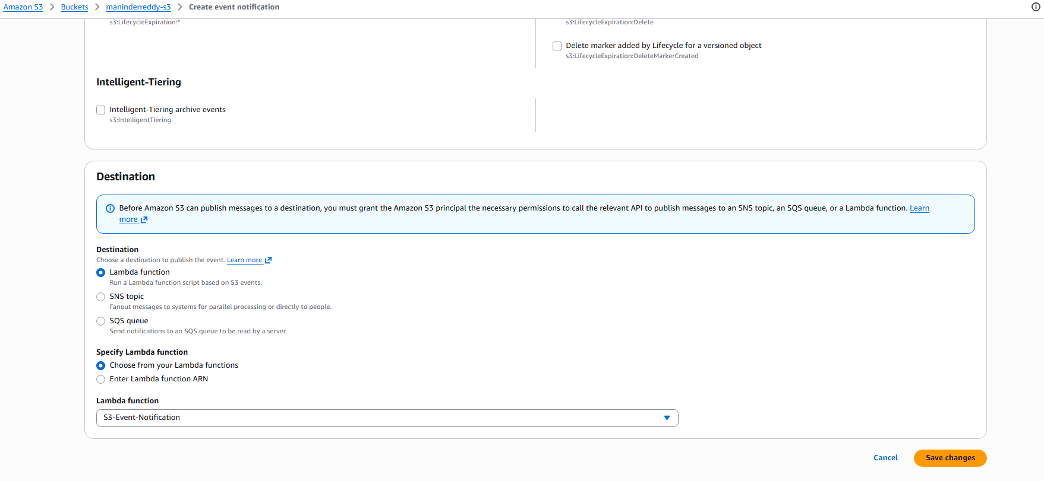
Step 5:
• Console path / CLI command:
AWS Console → SNS → Topics → Create topic
• Explanation:
Created an SNS topic and added an email subscription to receive notifications.
Evidence:
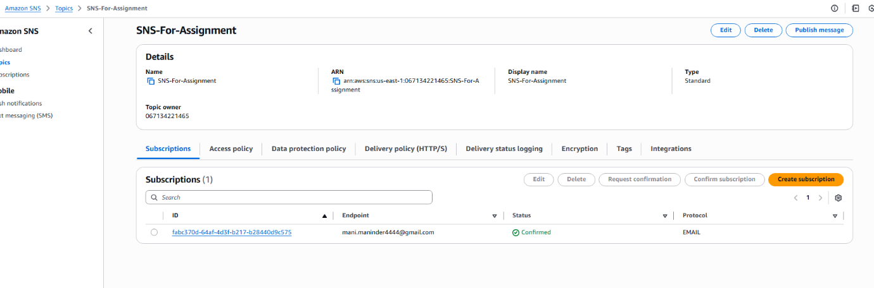
Step 6:
• Console path / CLI command:
AWS Console → Lambda → Function → Configuration → Destinations → Add destination
• Explanation:
Configured SNS as a destination for asynchronous invocation failures or successes from the Lambda function.
Evidence:
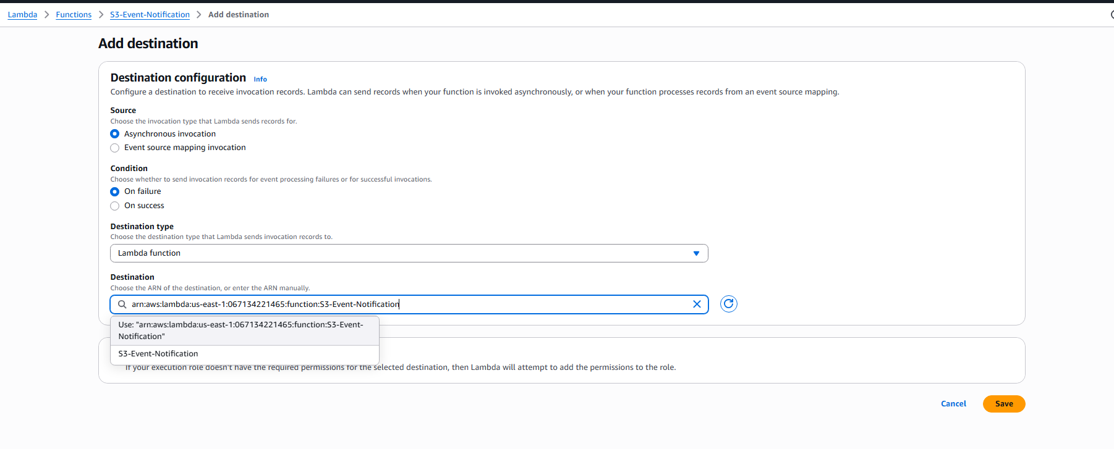
Step 7:
• Console path / CLI command:
AWS Console → S3 → Bucket → Upload object
• Explanation:
Uploaded a test file to the S3 bucket to trigger the event notification workflow.
Evidence:
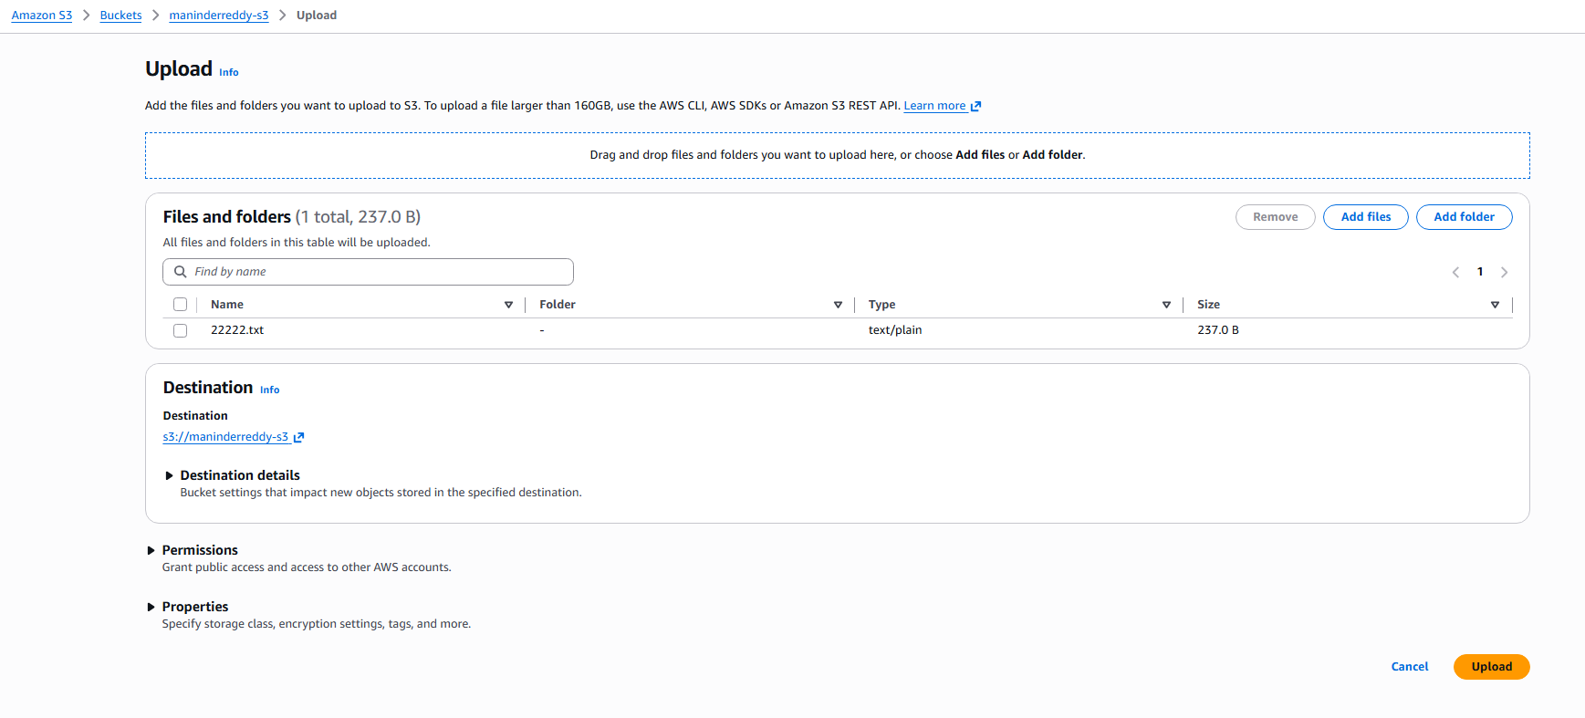
- Validation Steps (Mandatory, With Evidence):
Access Check
Example:
Email notification received for the S3 object upload event.
Evidence:
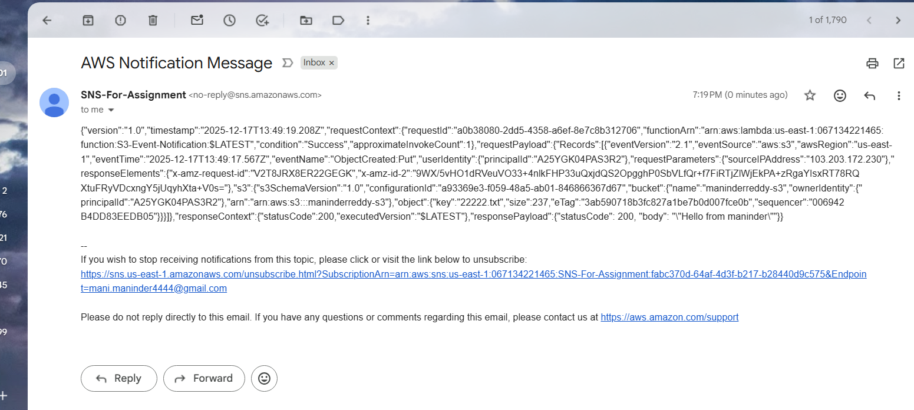
- Issues Faced (Optional):
I have first configured the sns notifications trigger for the failure and later I have changed to the success status trigger option, I was able to get the email notification with the lamda function output at the end.
- Conclusion:
The S3 Event Notification workflow was successfully implemented using Lambda and SNS. Object creation events in S3 now reliably trigger Lambda execution and send email notifications, validating end-to-end integration and monitoring.
2. API Gateway – Lambda Integration
- Task Title: API Gateway – Lambda Integration
- Objective:
To create an AWS Lambda function and integrate it with Amazon API Gateway so that HTTP requests sent to an API endpoint successfully invoke the Lambda function and return a response to the client.
Prerequisites:
AWS account
Lambda
API Gateway
- Step-by-Step Implementation (With Evidence):
Step 1: Create an AWS Lambda function
• Console path / CLI command:
AWS Console → Lambda → Functions → Create function
• Explanation:
A new Lambda function is created using the “Author from scratch” option. The function is named API-Gateway-Assignment, runtime is selected as Python, and default execution role is used. This function contains simple code that returns a static response message with HTTP status code 200.
Evidence:
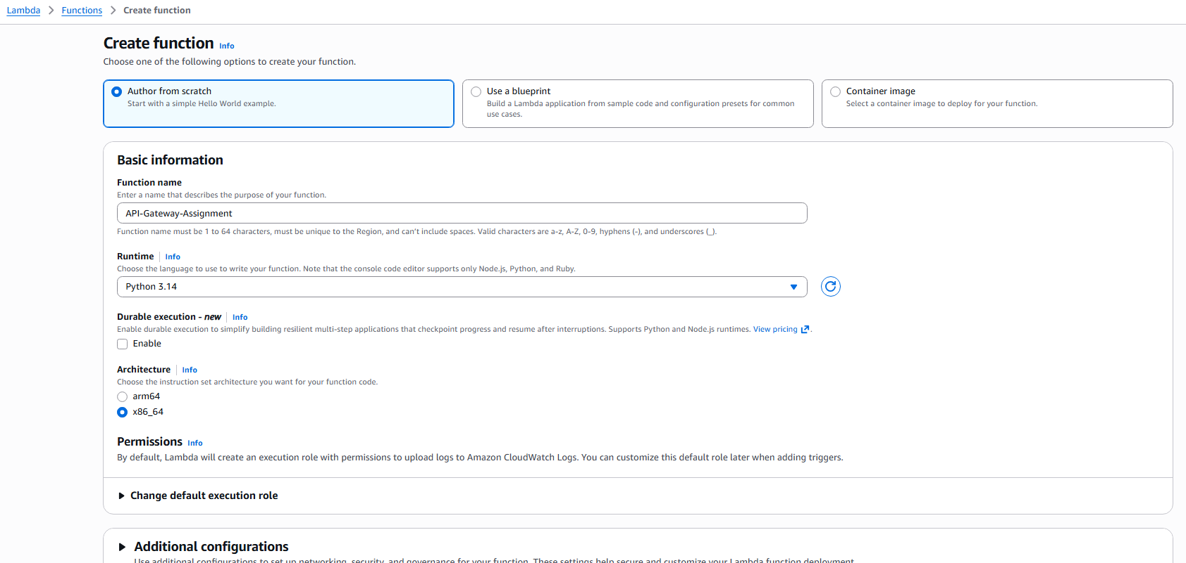
Step 2: Test the Lambda function independently
• Console path / CLI command:
AWS Console → Lambda → Functions → API-Gateway-Assignment → Test
• Explanation:
A test event is created and executed to validate that the Lambda function works correctly without any external trigger. Successful execution confirms that the function logic is correct and logs are generated in CloudWatch.
Evidence:
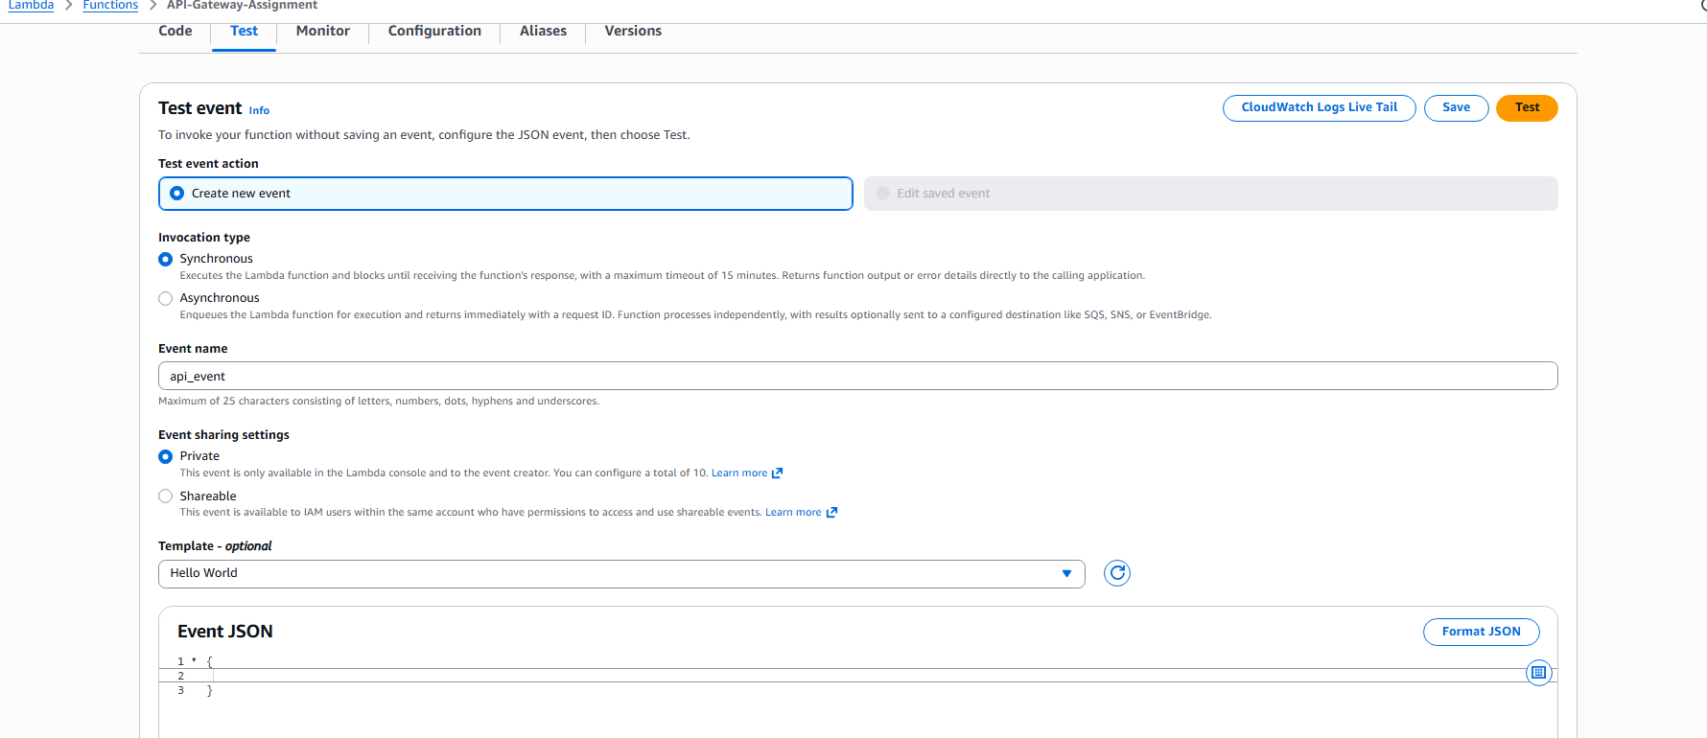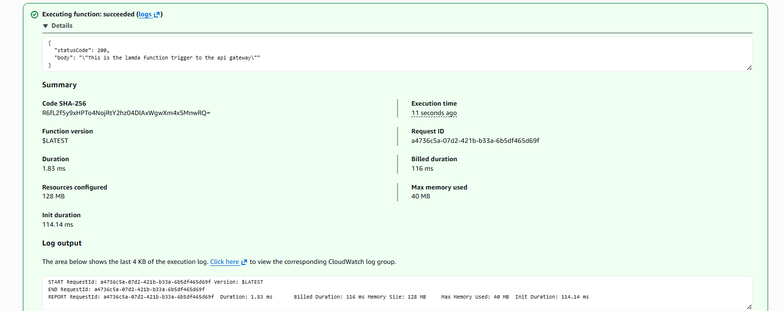
Step 3: Integrate Lambda with API Gateway
• Console path / CLI command:
AWS Console → Lambda → Functions → API-Gateway-Assignment → Add trigger → API Gateway
• Explanation:
An API Gateway trigger is added to the Lambda function. A new REST API is created with open security settings. API Gateway is configured to invoke the Lambda function when an HTTP request is received. Required permissions are automatically added to allow API Gateway to invoke Lambda.
Evidence:
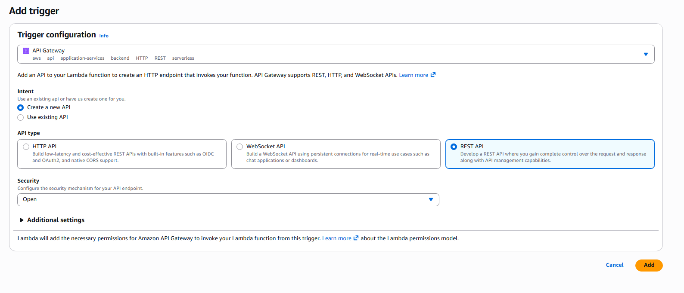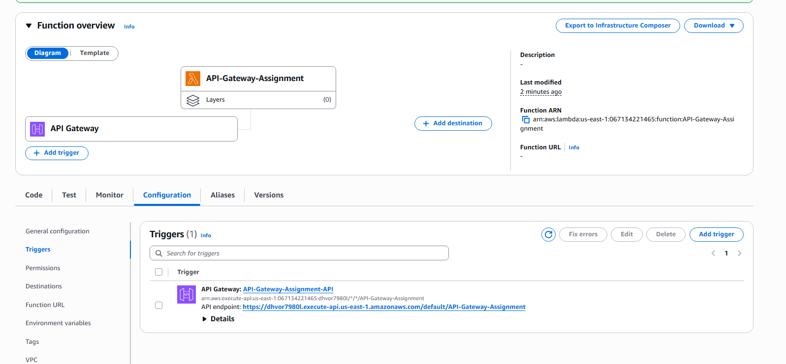
- Validation Steps (Mandatory, With Evidence):
Access Check
Confirm that API Gateway has permission to invoke the Lambda function via the attached trigger and execution role.
Evidence:
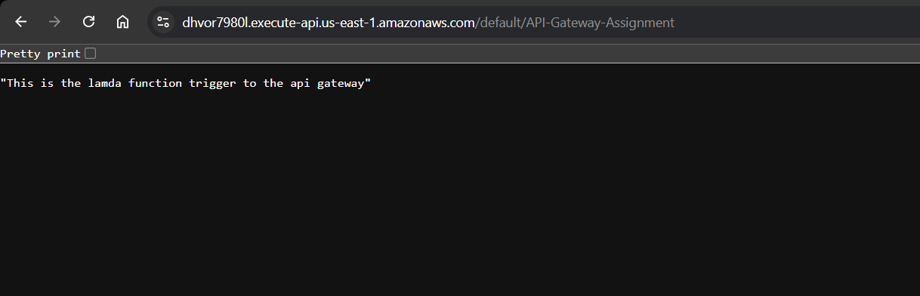
.
- Conclusion:
The AWS Lambda function was successfully created and integrated with Amazon API Gateway. The API endpoint correctly invokes the Lambda function and returns the expected response, validating end-to-end serverless integration.

